December 22, 2011

Women in the U.S. Military: Growing Share, Distinctive Profile
By Eileen Patten and Kim Parker
The women who serve in today’s military differ from the men who serve in a number of ways. Compared with their male counterparts, a greater share of military women are black and a smaller share are married. Also, women veterans of the post-9/11 era are less likely than men to have served in combat and more likely to be critical of the wars in Iraq and Afghanistan. In other ways, however, military women are not different from military men: they are just as likely to be officers; they joined the armed services for similar reasons; and post-9/11 veterans of both sexes have experienced a similar mix of struggles and rewards upon returning to civilian life.
Since 1973, when the United States military ended conscription and established an all-volunteer force, the number of women serving on active duty has risen dramatically. The share of women among the enlisted ranks has increased seven-fold, from 2% to 14%, and the share among commissioned officers has quadrupled, from 4% to 16%.
Department of Defense policy prohibits the assignment of women to any “unit below brigade level whose primary mission is direct ground combat.”¹ While this policy excludes women from being assigned to infantry, special operations commandos and some other roles, female members of the armed forces may still find themselves in situations that require combat action, such as defending their units if they come under attack.²
This report explores the changing role of women in the military using several data sources. Two Department of Defense publications — Population Representation in the Military Forces, FY2010 and Demographics 2010: Profile of the Military Community — provide the overall trends in military participation by gender, as well as demographic and occupational profiles of male and female military personnel.

Key Findings of the Report
- Growing Presence. From 1973 to 2010 the number of active-duty enlisted women in the military has grown from about 42,000 to 167,000. Over that same period, the enlisted force as a whole has seen a decrease of about 738,000 service members.
- Ranks. While a smaller number of women than men serve overall, a slightly greater proportion among the ranks of women are commissioned officers, compared with the share of men who are officers (17% vs. 15%).
- Demographics. The current active-duty female force is more racially diverse than the male force. Nearly one-third (31%) of active-duty women are black compared with only 16% of men, and a smaller share of active-duty women than men are white (53% vs. 71%). While military women are less likely than their male counterparts to be married (46% vs. 58%), those women who do marry are much more likely than men to wed someone who is also in the active-duty military (48% vs. 7%).
- Combat. Among living veterans from any era, only 15% of women served in combat, compared with 35% of men. Since the 1990s, changes in military policies and a decade-long conflict have contributed to an increase in combat exposure among women, from 7% among pre-1990 female veterans to 24% of post-1990 female veterans.
- Re-entry. The Pew Research survey finds that women veterans are just as likely as men to experience the struggles and benefits of service upon discharge — fully half say they experienced strains in family relations and 42% feel they have suffered from post-traumatic stress. On the other hand, 97% feel proud of their service.
- Opinions of the Wars. The Pew Research survey also finds that women veterans are more critical than their male counterparts of the wars in Iraq and Afghanistan—fully 63% say the Iraq war was not worth fighting and 54% say Afghanistan has not been worth it (compared with 47% and 39% of male veterans, respectively). Among the general public, by contrast, there are no significant differences by gender in the share who say the post-9/11 wars were not worth fighting.

December 22, 2011

Women in the U.S. Military: Growing Share, Distinctive Profile
Why They Joined
What compels young American women to join the armed forces? The answer is, to a large extent, the same things that compel young American men to join. In almost all aspects surveyed, the women’s reasons for joining the military were not significantly different from the men’s reasons.
More than eight-in-ten post-9/11 female veterans say they joined to serve their country or receive education benefits (83% and 82%, respectively). Fully 70% say they joined to see more of the world and almost as many (67%) say they joined to gain job skills.
However, there is one key difference in the reasons that men and women joined the military. Some 42% of female veterans say they joined the military because jobs were hard to find, compared with one-quarter of men.

By Eileen Patten and Kim Parker 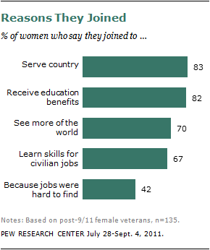

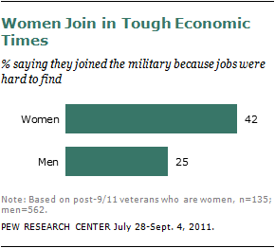

Returning from the Wars
Many of the experiences of female veterans from the post-9/11 military differ from those of men – they are less likely to have served in combat (30% vs. 57% of men)¹, more likely to have never been deployed away from their permanent duty station (30% vs. 12% of men) and less likely to have served with someone who was killed while performing their duties in the military (35% vs. 50% of men).
At the same time, however, they are equally likely to have had emotionally traumatic or distressing experiences while serving (47% vs. 42% of men), and their transition back into civilian life has been equally tough. More than four-in-ten female post-9/11 veterans (43%) say their readjustment to civilian life after their military service was very or somewhat difficult (along with 45% of men).
Furthermore, women are about as likely as men to report that they feel they have suffered from post-traumatic stress (42% vs. 35% of men), that they have frequently felt irritable or angry (45% vs. 47%), and that they have felt they didn’t care about anything (27% vs. 33%) since they left the service. They are also as likely as men to say they have experienced strains in their family relationships since their discharge from the military (50% vs. 48%).
Female veterans are also just as likely as their male counterparts to say they have experienced the positive benefits of military service. Fully 80% of women say they have appreciated life more since they were discharged from the service (83% of men say this). In addition, 97% say they feel proud of their service and 91% have had someone thank them for their military service (compared with 96% and 92% of men, respectively).
Female veterans and male veterans are equally likely to feel their military experience has paid off for them personally and professionally. Some 79% of women veterans say their military experience has helped them get ahead in life and nearly three-quarters (74%) feel the military was useful in terms of preparing them for a job or career (as do 73% and 71% of men, respectively).
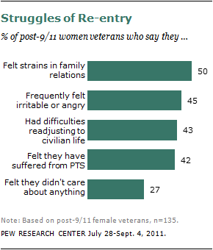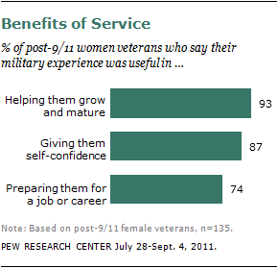
In addition to seeing it as a learning experience, female veterans see their service as a time of self-development. Fully 93% of women say their military experience was useful in helping them grow and mature as a person (along with the same share of men), and 87% of women say their military experience was useful in building their self-confidence, as do 91% of men.
More than three-quarters (78%) of women veterans say they would advise a young person close to them to join the military. This is similar to the share of men who would advise this (82%).

Views on the Wars
Yet while they’re proud and thankful of their service, post-9/11 women veterans are critical of the wars in Iraq and Afghanistan. When asked whether they thought the wars in
Iraq and Afghanistan have been “worth fighting,” 63% of female veterans say that the war in Iraq was not worth fighting and 54% say the same of the war in Afghanistan.
Here, the views of military women differ from their male counterparts. Among male veterans, less than half (47%) were critical of the Iraq war and only 39% were critical of the war in Afghanistan.
This gender gap is not as apparent among the general public. In a Pew Research survey conducted Sept. 1-15, 2011, men and women as a whole expressed similar views about the wars in Iraq and Afghanistan, with narrow majorities of both saying the wars were not worth fighting.

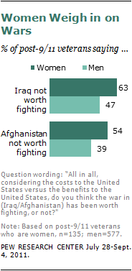

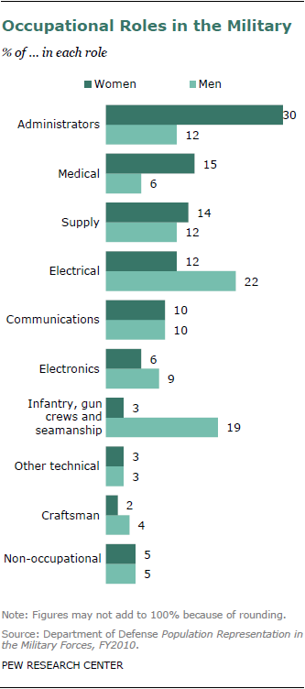

In the early 1990s, the Department of Defense changed its policies in a way that allowed women to serve in a greater variety of combat-related roles, such as flying in combat aircraft and serving on combat ships. This has led to a sharp rise in the share of female veterans who have served in combat zones — from 7% in pre-1990 eras, to nearly a quarter (24%) among those who served since 1990.
There are several other differences in the occupational distribution of men and women in the military.
Active-duty women are much more heavily concentrated in administrative and medical roles than are active-duty men. A plurality of women in the military (30%) are in administrative positions, compared with only 12% of men. And while only 6% of men in the military hold medical roles, 15% of women have these types of jobs.
Occupational roles in the electrical field are the only jobs other than infantry that are overwhelmingly dominated by men. While 22% of men are in electrical positions, only 12% of women serve the same roles

